**React Native Show SuperScript and SubScript**

React Native SuperScript SubScript is a React Native Version of tags available in HTML known as <sup> superscript and <sub> subscript.

Superscript tag sets the half of the character above on the text writing line like **(10am)** and the same as but in a different manner the Subscript tag is opposite of superscript, In subscript tag, the next character would be halfway down to the previous one like **(10am).**

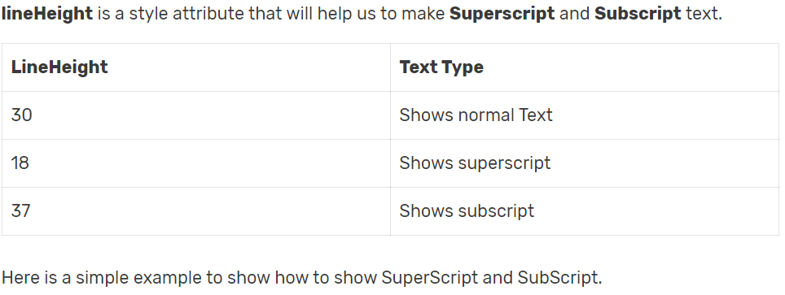

**Show SuperScript Using**

<**Text** style={{fontSize: 15, lineHeight: 18}}>am</**Text**>

**Show SubScript Using**

<**Text** style={{fontSize: 15, lineHeight: 37}}>am</**Text**>

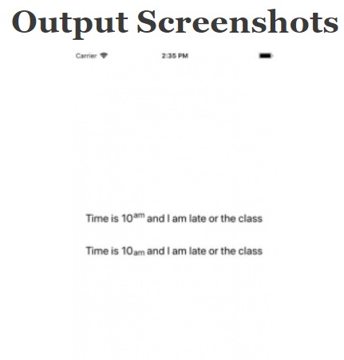

//This is an example code to show SuperScript and SubScript//

import React, { Component } from 'react';

//import react in our code.

import { StyleSheet, Platform, View, Text } from 'react-native';

//import all the components we are going to use.

export default class Project extends Component {

render() {

return (

<View style={styles.MainContainer}>

{/*View to wrap multiple text*/}

<View style={{flexDirection: 'row', alignItems: 'flex-start'}}>

{/*View to wrap multiple text*/}

<Text style={{fontSize: 20, lineHeight: 30}}>Time is 10</Text>

{/*Superscript*/}

<Text style={{fontSize: 15, lineHeight: 18}}>am</Text>

<Text style={{fontSize: 20, lineHeight: 30}}> and I am late or the class</Text>

</View>

<View style={{flexDirection: 'row', alignItems: 'flex-start', marginTop:30}}>

{/*View to wrap multiple text*/}

<Text style={{fontSize: 20, lineHeight: 30}}>Time is 10</Text>

{/*Subscript*/}

<Text style={{fontSize: 15, lineHeight: 37}}>am</Text>

<Text style={{fontSize: 20, lineHeight: 30}}> and I am late or the class</Text>

</View>

</View>

);

}

}

const styles = StyleSheet.create({

MainContainer: {

flex: 1,

justifyContent: 'center',

alignItems: 'center',

paddingTop: Platform.OS === 'ios' ? 20 : 0,

margin: 10,

},

});